
Group Assessment Cover Sheet

Unit number: | ICT308 | Unit name: | Project 2
Lecturer or Tutor name: | Dr Nam Hoai Chu
Student ID number | CIHE 240275  CIHE 241526  CIHE 231576  CIHE231760
Student name | Prajwal Shrestha  Rahool Thapa  Tsheing Tshering  Kusal Tiwari

Submission Title: | Front-End Development
Word Count: |  | Due date: | Week 5 | Date submitted:

ICT308 Assessment 1 – Front-End Development Report

Part 1: Design Documentation

1. Introduction and System Overview
The CreekWatch (EMS) Environmental Monitoring System is internet relied application, developed with the intent of collecting, validating and analysing environmental data like temperature, turbidity, dissolved oxygen, ph levels, and many other elements of multiple monitoring sites and display interactive real-time dashboards, trigger alerts and generalize the trend. Our web based application allows the users to upload structured environmental data, (has to be structed according to our monitoring template, else the parsing will trigger an error) through CSV files, which are parsed from the system then processed and visualised through an interactive dashboard with triggers, flexible filters and location of the site in the map.
We created this system with the purpose of streamlining environmental monitoring with the intent of possibly revoking manual data handling like using handheld tools e.g., thermometers, pH strips, writing results in notebooks or spreadsheets, looking at conditions of water clarity, or pollution and calculating averages, or trends manually through strict observation and updating this redundant labour with a structured, automated and fully digital workflow. The interface of the application is poised by different user roles, which include public users (they can view the monitored environmental elements, like dashboards and alerts), volunteers (they can upload CSV files for parsing), and coordinators (have access to triggers, backend data and system performance).
Our system follows a clear data pipeline:
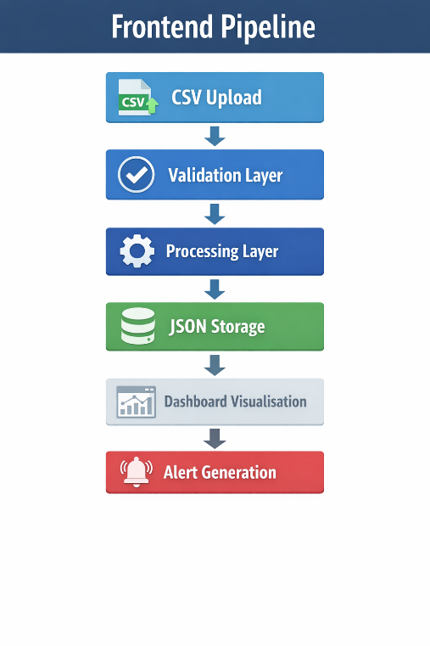
We did some research and came up with this approach to maintain data integrity and manifest real time insights and convert them into environmental conditions.

2. Business Rules and System Requirements
Our application is intentionally integrated with structural data compliances to corroborate that all environmental quality measurements and metrics are parsed and evaluated accordingly to our system without any defaults. We came up with this format by observing other contemporary environmental quality measurements and thought, it would be axiomatic for people to upload an CSV file, assuming the environmental metrics or measurements they got is already in normal parsing order.
As mentioned above, the format we adopted was from contemporary environmental measurements. So for all uploaded CSV files, the data inside those files must contain a predefined set of required columns. These include site name, latitude, longitude, date, time, pH, turbidity, dissolved oxygen, temperature, and E. coli levels. These are the elements that are present and recognised by our application, and files missing any of these columns will be rejected by our system during parsing with a prompted error template.
After the previous step is successfully completed, each row of data will go through the parsing process and if everything in order, successfully pass the validation checks. Our system expects the data value to be present, also numeric fields to be filled with valid numbers, and finally, all data values to be within acceptable ranges. To clarify the previous sentence, we have set international calibration standard for the environmental elements, and also the threshold exceedance. For example, pH values must be between 0 and 14, temperatures must be within the pre-set calibrated range, and the coordinates must be geographically accurate.
Coming onto the international calibration standard, our application is bound to these environmental threshold rules which facilitates the system to recognize the quality of the respective element. Let’s say, for water, turbidity values above 8 NTU (how cloudy the water is), E. coli (a bacteria form animal or human waste) levels above 300 CFU/100mL, or pH (acidity or alkaline present) values outside the range of 6.5 to 8.5 signals bad or toxic environmental conditions. Henceforth, every respective element has their own standardized calibration and threshold exceedance which reveals the elements acceptable or degraded conditions of the environment. In a nutshell, if an element, water, let’s say is cloudier than the standard calibration, has immense E. coli bacteria or its pH is outside the safe spectrum range, our system suggests the water quality to be contaminated and unsafe which triggers our built-in alerts.
Continuing with the alerts, the threshold exceedance is configurated to detect abnormalities at a certain value, which is mentioned in the paragraph above, which subsequently trigger alerts. Alerts are categorised by severity and include information such as location, time, parameter, and recorded value. For e.g. it’ll come up like this:
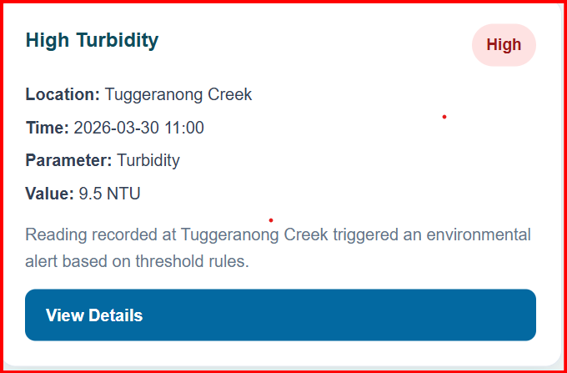
The interface in alert page highlights the abnormal environmental conditions mentioning the which the location of the creek, when it was taken, the parameter of the alert, parameter value which subsequently can be identified and reviewed by the users.
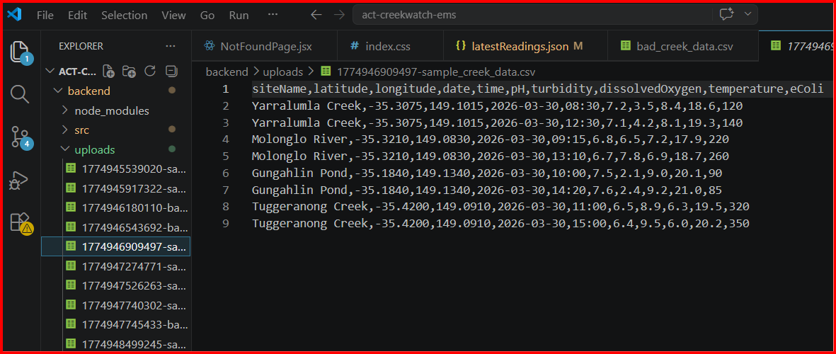
Finally, validated data is stored in JSON format which uses standardised measurement rules, meaning all the data follow the same format and limits. This consistent data structure, facilitates to organize, compare and display data on dashboard inside the web application.

3. Project Management Using Jira
We leveraged Jira as the focal project management tool to structure, plan and allocate all the personal activities for our ongoing ACT CreekWatch EMS project. The framework for our project is divided into three primary epics: Front-End Design and Development, Back-End Development (Iteration 1), and Testing, Refinement, and Final Presentation.
These epics are then refined into granular actions and tasks that are aligned with the respective epic’s objectives. For instance, Front-end design and development epic consist of mini actions starting from designing home layout and structure which is then blocked by building navigation bar. Navigation bar is then blocked by design homepage layout and there are other task which are linked together as well, like implementation of homepage hero section, building forms and reusable UI components, and conducting responsive design testing, all these tasks are interrelated and linked to one another for the purpose of clarity and clear direction of our objectives for our team members to achieve responsive and working layouts. Every epic, plus their respective tasks, has a clear description of the mini steps for the specific task which in taken in account for clarity and transparency for the team. Plus, artificial timeframes are allocated to the respective epic and specific task to keep track of our objective and progress.
For the back-end, it shares the similar structure and framework as the frontend in Jira. Each and every epic and tasks are descriptive with mini actions, linked to each other, with are later attached with allocated timeframe for the respective epics and task for keeping track and simplifying operations. The task is performing the CSV data pipeline, including file upload handling, data validation, processing, and API development to support data retrieval. And in the end, testing refinement and final presentation includes tasks like preparing acceptance testing documentation, conducting usability testing, refining Iteration 2 deliverables and final documentation, preparing group presentation slides and finally delivering the final presentation, of course, with clear descriptions, connections and timeframes.
We had to allocate the responsibilities for this project by taking in our team member strength and weaknesses into consideration on the coding prowess. Firstly, we decided to assigned Rahool to be involved on front-end side of things, especially user interface design and page structuring. While Tashi is assigned to contribute to the back-end development and testing side of things, he bears the responsibility for the accurate data processing and stable system performance. Then Kushal is supporting the team mostly with testing activities while also assisting with presentation preparation. Finally, Benji is assigned with cross-functional role, he’s taking care of back-end development system integration along with Tashi, taking care of bugs in the system, and overall looking after project coordination which includes embedding CSV processing logic, implementing front-end and back-end components, fixing system issues, and making sure the application is functional.
Henceforth, considering all the logic mentioned above, we can conclude having a strong Jira based task allocation, progress tracking, and effective team coordination which will be indispensable for completing our ACT CreekWatch EMS project.
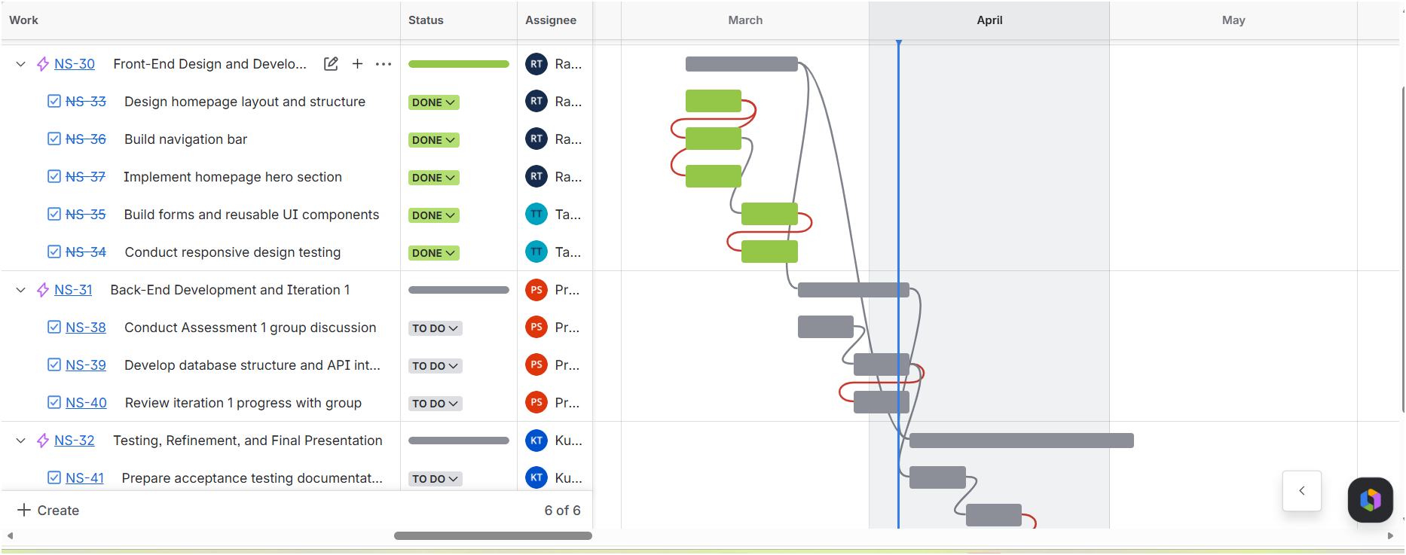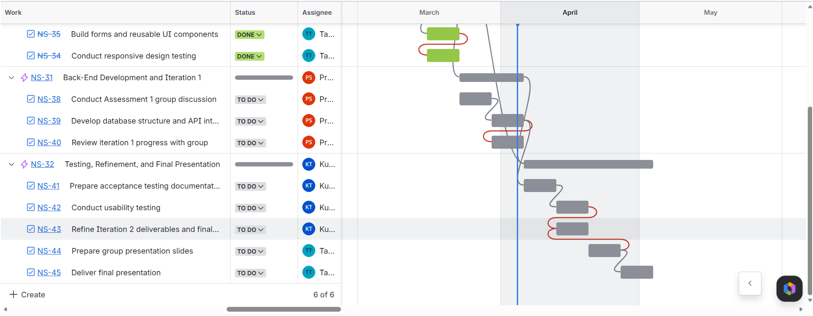
Link for Jira:
https://cihe1234.atlassian.net/jira/core/projects/NS/timeline?atlOrigin=eyJpIjoiZmRmZjcxOGMzODhmNDViMmEwODkyYjE3Nzc4MmNlNjAiLCJwIjoiaiJ9

4. Front-End Design and User Interface
The front-end part of ACT CreekWatch EMS was instigated and developed using Vite-React with multiple pages, including homepage, public dashboard, volunteer dashboard, CSV upload interface, alerts page, and coordinator dashboard. Each page is created with a specific purpose in according to user tasks and roles within the system. The navigation bar is frozen throughout all pages, for users to toggle in-between tabs.
Homepage manifests environmental parameters such as pH, oxygen levels, temperature, and status using card-based layouts. Following this, public dashboard shows measurements of the elements and reflects it through metric cards and trend charts. Parameters such as pH, turbidity, dissolved oxygen, temperature, and E. coli are shown with clear values and units plus, users have filter option too.
The volunteer dashboard is the one of the main backend driven page. It shows total uploads, sites visited, alerts triggered, and parameter quality all these data are reflected live after the parsing. We’ve also incorporated recent upload function and achievement badges for fun. Similarly, coordinator dashboard shares a similar function. The page provides a system-wide view, including total uploads, alerts, monitoring sites, and system status of all the data collected.
This is the where all the magic happens. For data submission, CSV upload page prompts users to upload files using either drag-and-drop or file selection. A progress bar and validation feedback are also displayed during upload. And on the right hand side, a history panel shows all the previously submitted files and their validation results. Finally, when triggered alerts page reflects threshold exceedance warnings in a card base layout, including location, parameter, value, and time. Severity levels are highlighted using labels such as moderate, high, low and by colour indicators.
We utilised React Router to navigate in-between pages to avoid reloading the application, with possible refreshing glitches in mind. Again, data cards, navigation bars, and alert panels are implemented as well. RWD techniques are present so the web application front adapts according to the screen sizes. Most of the things about the frontend is written in business rules and system above. Please go have a refresher at the top if needed.
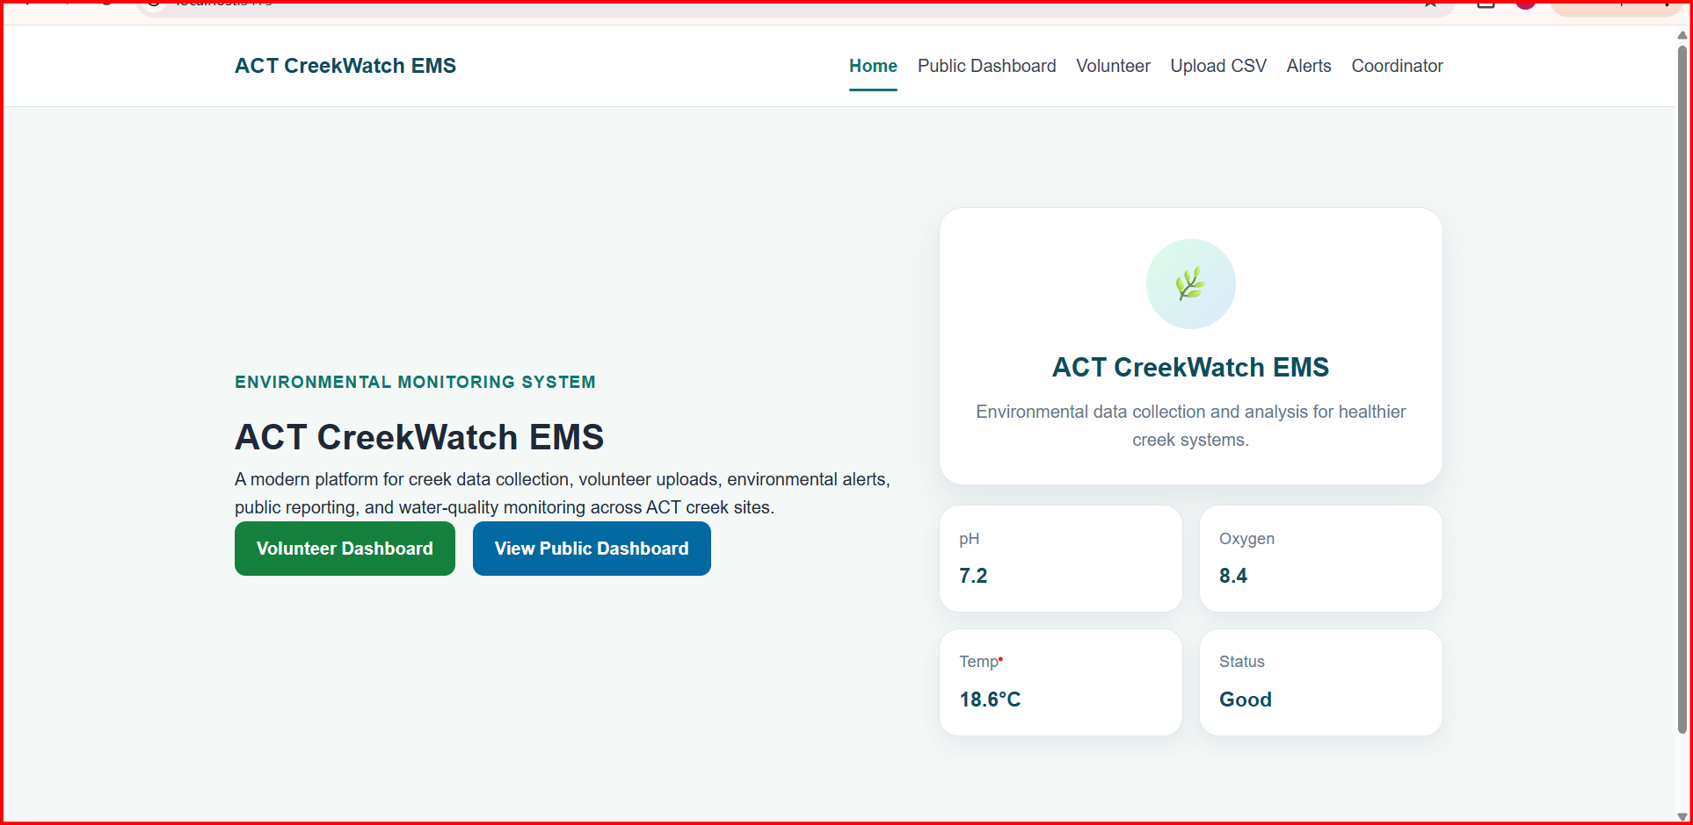
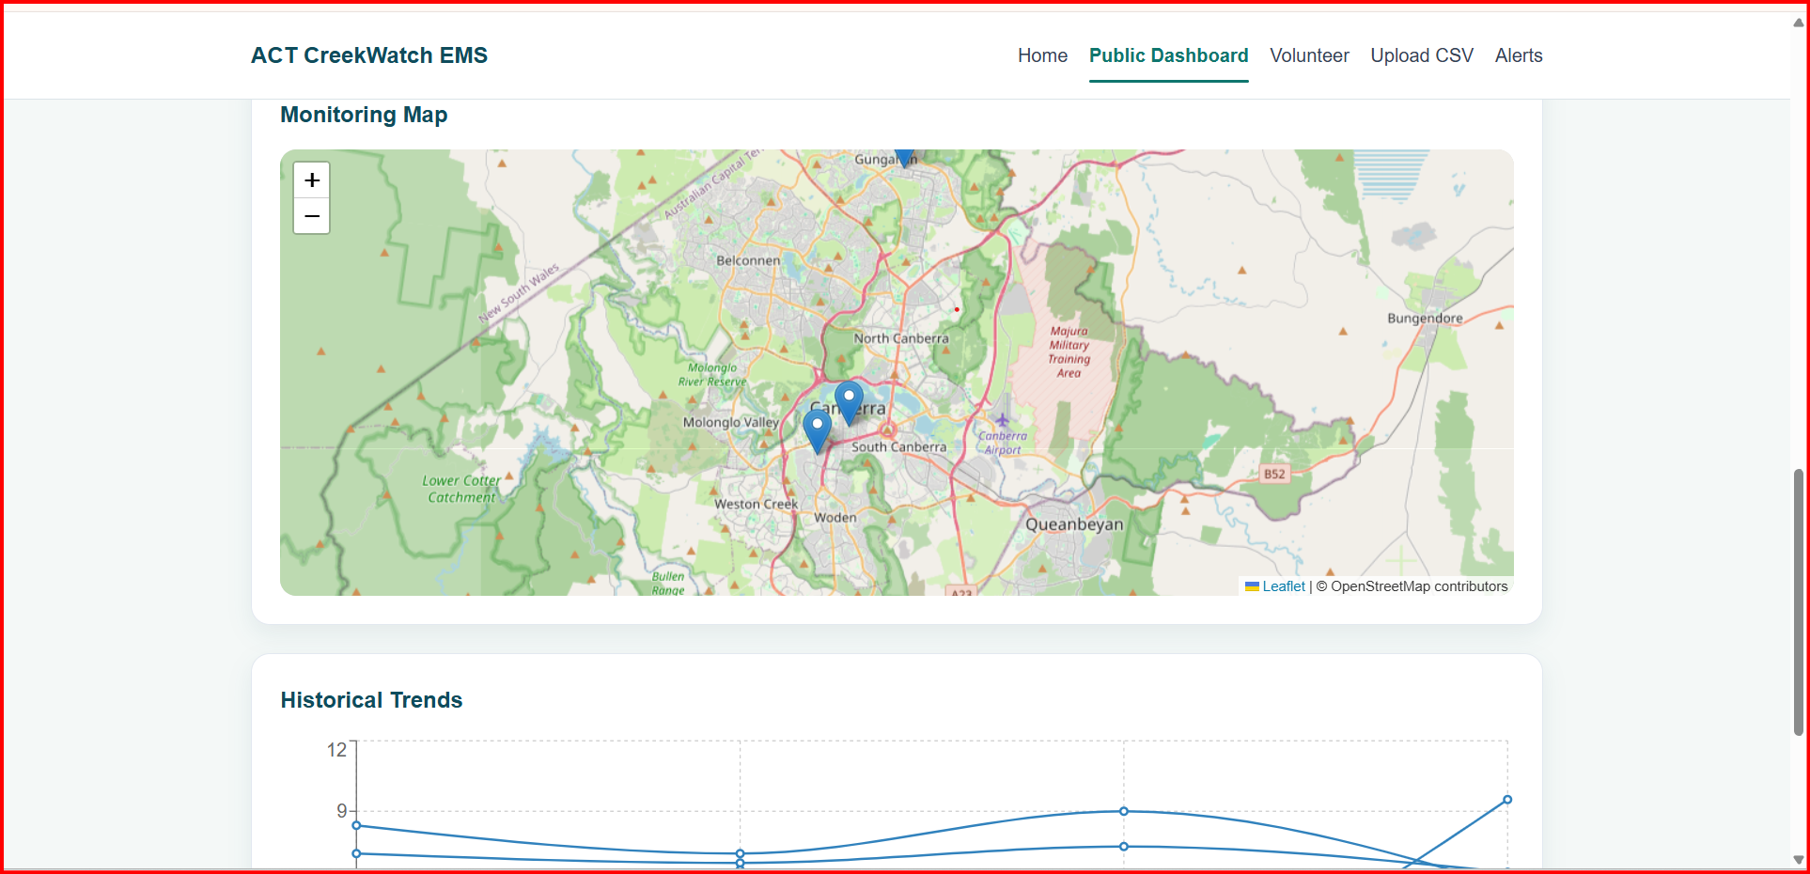

5. Data Storage and System Architecture
We decided to go with JSON-based data storage for our web application discarding the traditional relational database. The environmental data and metrics we receive, is then stored in JSON files, including latestReadings.json and alerts.json. These files contain aligned structural format data we embedded in our system such as parameter values, location, time, and alerts. We did this for the purpose of letting frontend to rapidly get hold of the data and show information without reprocessing the whole CSV files which if done would be prone to errors. This strategy streamlines the frontend integration and will be a catalyst for the benefit of the project.
Inside the volunteer page, we have a feature for uploading CSV files and when it is uploaded by users, the data is then parsed and converted into JSON format. This approach is taken with the intent of complying all data structure consistency. The backend reads and writes to these JSON files to store new values and alerts, and structure and format them accordingly to the frontend criteria and when csv data is parsed, the newly formatted readings are saved in latestReadings.json, and the threshold breaking limits are then stored and recorded in alerts.json. Finally, these refreshed dataset is then captured by the frontend to show updated dashboard readings and alerts.
For the frontend architecture, a component based React architecture is made as a single-page application consisting presentation layer (pages), reusable UI components, and a service layer for API communication. State is controlled using React hooks, incorporated with dynamic updates such as filtering, chart visuals, and data rendering. A rough diagram of our architecture is presented below:

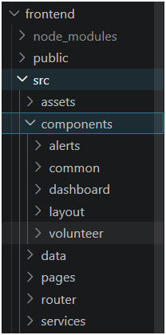
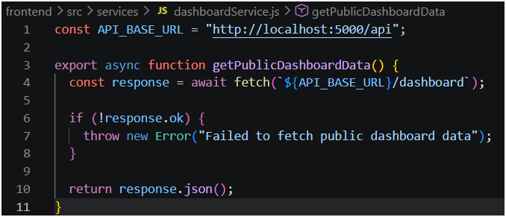
Fig; frontend and backend communication
Fig; Layered system architecture inside VSC

User Interaction (Click, Upload, Filter)
│
▼
React Pages (Presentation Layer)
│
▼
Reusable Components (UI Layer)
│
▼
Service Layer (API Calls - Fetch)
│
▼
Backend API (Node.js / Express)
│
▼
JSON Response (Dashboard / Alerts / Uploads)
│
▼
React State Update (useState / useEffect)
│
▼
UI Re-render (Charts, Cards, Alerts Updated)

Part 2: Development Process
Part 2 – Development Process and Front-End Implementation
Our frontend application was developed as a web based application by using React, with Node.js and npm which were used to manage dependencies and run the project. Most of the development was carried out in Command prompt since our Visual Studio Code wasn’t supporting npm plus the VSC terminal wasn’t as friendly as the cmd prompt, but all the codes and structure were stored in VSC.
We didn’t use platforms like WordPress or pre-built templates, our interface was built completely from scratch as you will see when we run the server, it’s not a complicated structure. The fact that we didn’t have to stick to a strict template encouraged the team to be more creative and have full control over the aesthetics of the system and its behaviour.
Front-End Structure and Design
As mentioned above, our frontend follows a component based structure. The application is organised accordingly into several parts with the purpose of keeping things clean and easy to manage:
- Pages helps view Public Dashboard, Volunteer Dashboard, CSV Upload page, Alerts page, and Coordinator page
- Components are reused throughout the system like data cards, status indicators, alerts, and charts.
- Services deal with communication with the backend using API calls
And Navigation between pages is using React Router, so the system behaves in a single page application without reloading the browser like normal browsers.
User Interface and Layout
Our frontend interface was designed using custom CSS. We didn’t use any external UI libraries. A simple dashboard style framework was chosen so that the users don’t find it difficult to comprehend the environmental data. Parameters are mentioned and explained below for clarity for normal audience.
Information is displayed using:
- cards for key metrics (such as pH, turbidity, and temperature)
- charts of trends over time
- alerts cards
- maps to show locations of the creeks

Custom Features and Improvements
We implemented filtering feature to toggle between the sites and get their specific readings and alerts. The system is dynamically updated when filters are applied, and summary values are recalculated and alerts and charts updated. The CSV upload page has a drag-and-drop interface that is validated allowing the user to get a response when the file format is not the correct one and we also incorporated a feature right above the drag and drop interface named ‘Download Sample CSV Template’ which lets user download the sample CSV template to check their formatting.
The alert system shows the latest alerts and provides users with the opportunity to see the severity of the alert, plus, they also have the ability to export the environmental alerts in CSV format.A parameter guide is included under the chart to clarify the meaning of each value and the usual ranges of each value. Moreover, the most recent readings have colour-coded indicators (normal, warning, critical) to allow the users to be immediately informed about the possible problems
Hosting and Deployment
Our web application runs in a local server, where the frontend and the backend need to be initiated on the terminal, we use command prompt for ours, during testing and integration. The backend runs through the cmd- npm run dev which starts this server http://localhost:5000/,.Quick note: the cmd must be initiated on our project backend directory, as well as, the frontend directory which starts this server http://localhost:5173/. If we execute these two steps, the server allows our frontend to fetch information back and forth between frontend and backend such as environmental metrics, dashboard data, and alerts, uploads and so on and which completes the whole hosting process leading to a full functioning web application.:
Our web application isn’t run on a platform like GoDaddy or WordPress like mentioned in the assignment, but our application is configured in a way to be possibly deployed to cloud platforms such as AWS in the near future. We made sure our configuration for this project was cloud friendly just in case we want to incorporate it in our system.
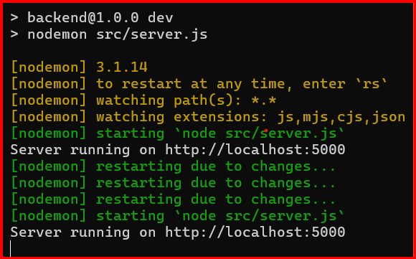
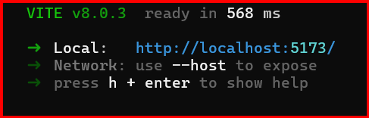
.

Conclusion
Taking all the information mentioned above into consideration, CreekWatch (EMS) Environmental Monitoring System is an integration of front-end and backend servers and dependencies to host a functional environmental monitoring platform for parsing CSV data and simultaneously displaying it on the dashboard and indicating alerts triggers with bright colors, measuring the environmental threshold breaches according to an elements specific unit, and reflecting it to all the users.
Following a clear direction with project management through Jira, we managed our team to deliver a presentable and working system within the project timeline. We had some setbacks and difficulties especially relating to npm installation, VSC terminal, Github, json errors, CSV validation errors, incorrect API endpoints, backend servers not running properly or even crashing, alerts were not reflecting new data, frontend-backend communication issues and so much more. Fortunately, these were successfully rectified through problem solving and iterative development.
Finally, our web application manifests rudimentary principles of modern web development, including standardized data structure, backend and frontend system integration, and user friendly design. And in the near future, improvements could be made including the implementation of a full database system and possibly a real time data streaming capability.

Student’s signature:
Note: An examiner or lecturer/tutor has the right to not mark this assignment if the above declaration has not been signed.

Crown Institute of Higher Education Pty Ltd ABN:22 611 573 301 TEQSA Provider ID: PRV 14301 CRICOS Provider Code: 03744B
116 Pacific Highway North Sydney NSW 2060 P 02 9955 0488 F 02 9955 3888

Crown Institute of Higher Education Page 1 of 1

